Use a serial port as a Counter/Interval timer/Frequency meter
Richard L. Grier
Hard & Software
Copyright © Richard L. Grier 2012

A RS-232 serial port may be used as a counter/timer and frequency meter, with certain limitations. This application uses of one of the hardware input handshaking lines to count pulses and to make measurements in code based on pulse timing. This example uses the Carrier Detect (DCD) input line plus ground, but either Dataset Ready (DSR) or Clear to Send (CTS) input lines might be used instead.
What are the limitations that I speak of? Speed is the primary issue. We are not using any external hardware to measure intervals or counts, so we are dependent on the PC speed, software latency, and the timing precision offered by Windows to do the calculations required for these measurements. In general terms, pulse repetition rates of less than 1000 per second (.01 S pulse intervals) may be done fairly accurately. It is possible to recognize and respond to higher pulse repetition rates, though the measurement accuracy degrades substantially – and rates in excess of 2000 per second simply cannot be used; and some hardware, such as USB serial adapters, may not provide full resolution at the highest rates.
Here are some screen shots that show how the example code responds to input pulse streams. First, I’ll show an oscilloscope screen and then the resultant display from the example code.
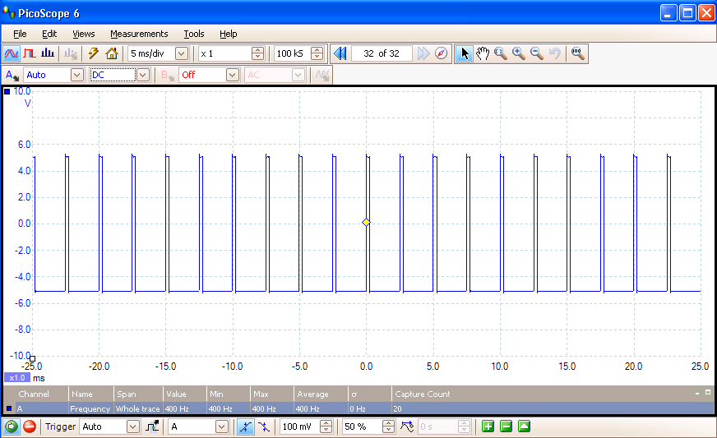
Figure 1a, 400Hz
The above pulse train (and lower rate inputs) displays fairly accurately.
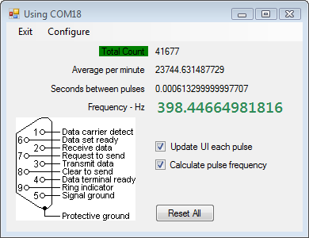
Figure 1b, 400 Hz
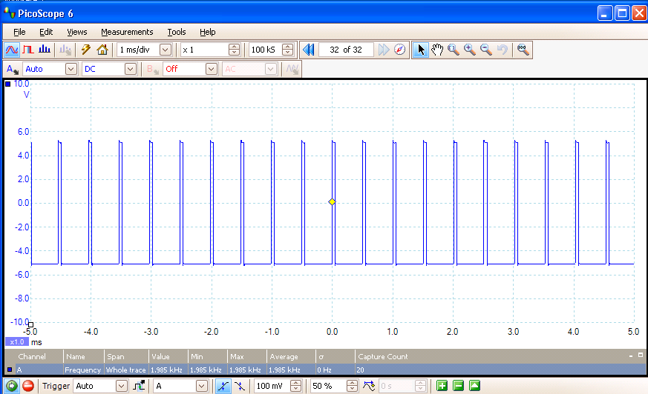
Figure 2a, 2000 Hz
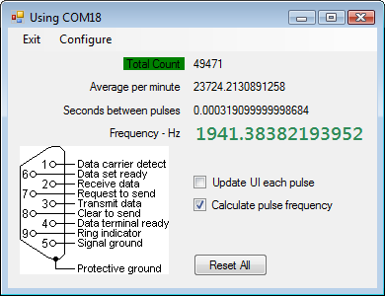
Figure 2b, 2000 Hz input
Note the above pulse train is measured with about a 2% error. This error is caused, primarily, by software latency. Repetition rates higher than 2 KHz result in much higher degradation.
Note, I’ve included a checkbox to disable display of Total Count, Average per minute, and Seconds between pulses. There are two reasons not to display these calculations when each pulse is detected. First, the user cannot perceive changes of these readings at pulse repetition rates much in excess of 10 per second (10 Hz), and second, because such display introduces some additional software latency, degrading the frequency calculation measure substantially at high rates.
I’ve shown pulse interval measurements. What about sinusoidal input waveforms?
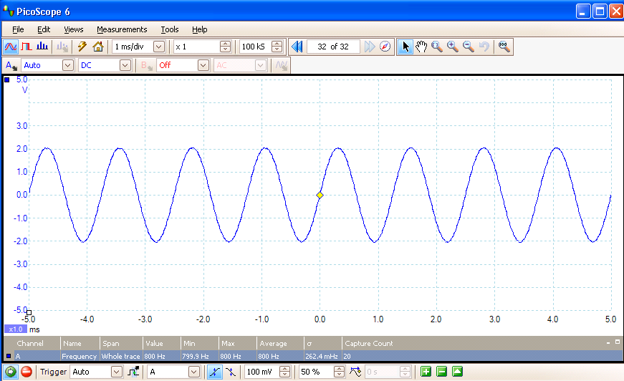
Figure 3a, 800 Hz sine wave
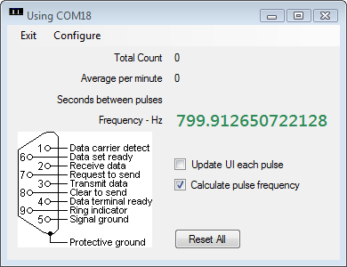
Figure 3b, 800 Hz sine wave
As you see, measurement with a sinusoidal input is satisfactory. Other wave shapes, such as triangular waveforms will be satisfactory. More complex waveforms may be measured, though the frequency displayed will not be any accurate measure of the spectral content may be more important than the basic frequency, thus other methods will be more appropriate.
The Visual Basic (VB NET 2010) source code for the above project is included with my book, Visual Basic Programmer’s Guide to Serial Communications 4. To order a copy go to: http://home.comcast.net/~hardandsoftware/books2.htm

