Square wave Generator using a RS-232 serial port
Copyright © Richard L. Grier
Hard & Software
www.hardandsoftware.net

This article describes two techniques to generate and output a squarewave via a PC RS-232 serial port. There are some limitations to this technique, which I will outline here:
- The “standard” RS-232 output voltage range is ± X volts, where X might be as low as ± 3V and might be as high as ± 12V. The nominal voltage range for a USB serial port adapter is ± 6V and perhaps ± 9V for a built-in or add-on hardware RS-232 serial port. These voltages will vary from manufacturer to manufacturer. If you need a 0-5V nominal squarewave, you will have to add a simple clamping circuit. For example, this following simple circuit will do the job for the frequencies that can be generated using the programs described here.
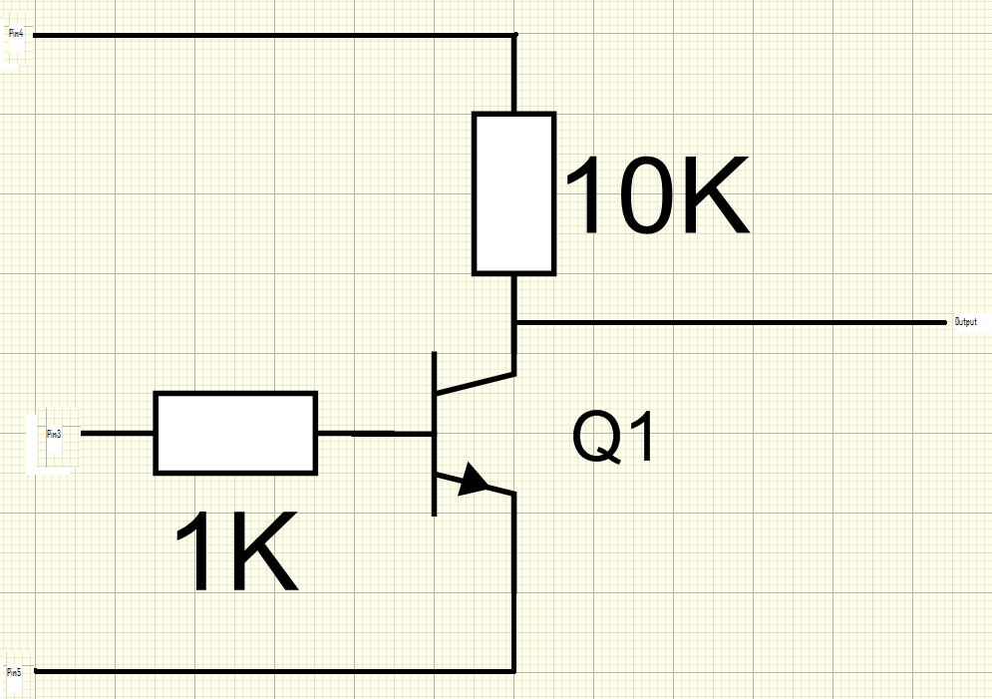
Connect +5V from your circuit to the 10K resistor, connect RS-232 Tx (pin3) to the 1K resistor, connect RS-232 Gnd (pin 5) to the transistor emitter, and connect the transistor collector (output) to your circuit. DTR provides power for the circuit. Also, connect RS-232 Gnd (pin 5) to your circuit ground.
- The maximum frequency (repetition rate) is 57600 Hz. The minimum rate is 4.66 E-7 Hz, though this low rate would be hard to observe!
- Higher speeds are possible using specialized serial port hardware than is designed to operate at speeds as high as 921600 bps, which might be used to generate squarewaves of up to 460800 Hz.
The following figures show low frequency squarewave generation up to 100 Hz. The technique used is to modulate the Tx pin using the SetBreak method of the SerialPort control. SetBreak = True causes the Tx pin to go to a low state, while SetBreak = False causes the Tx pin to go to a high state. Modulation consists of timing the True and False duration in a background thread. Since this uses Windows to calculate these durations, the resolution is limited to 1 mS, and the maximum reliable repetition rate is 100 Hz.

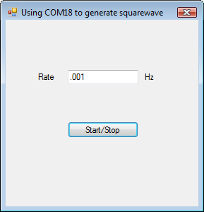
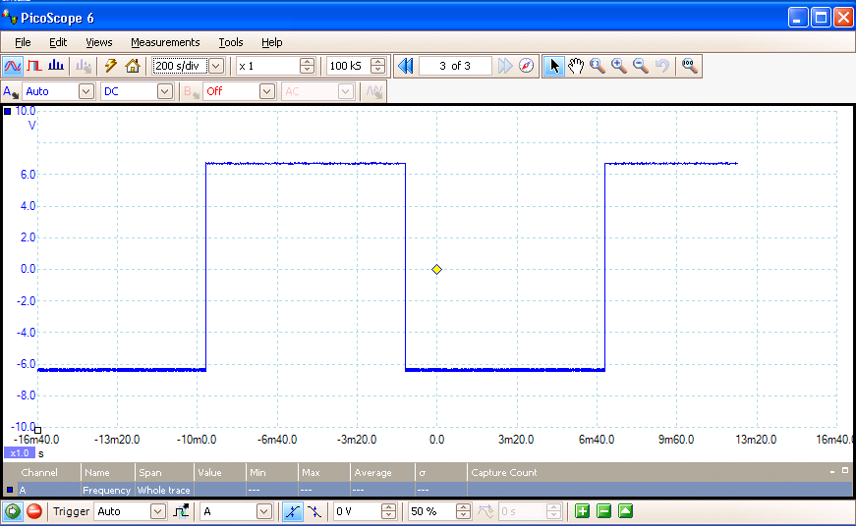
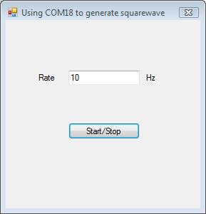
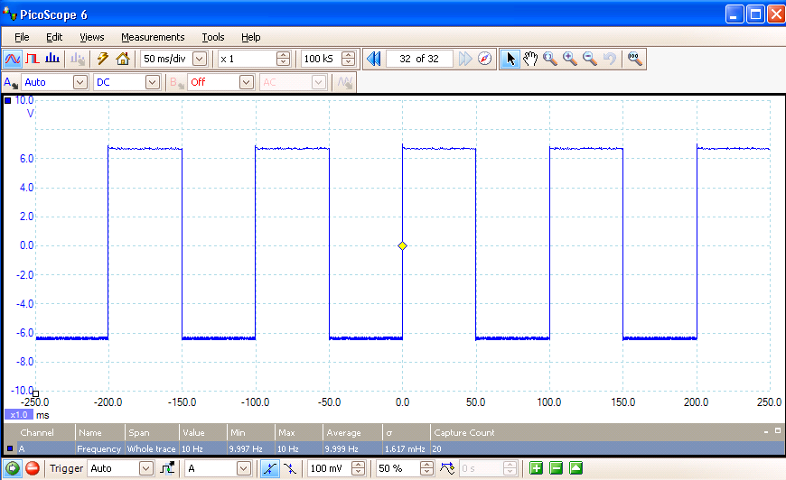
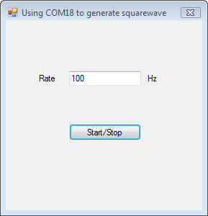
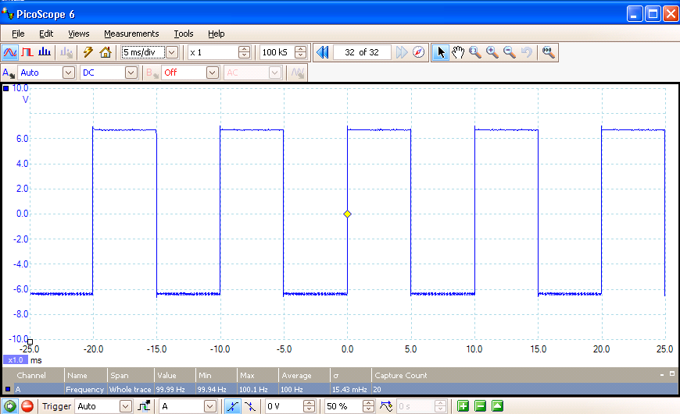

Rates between 100 Hz and 57600 Hz use a different technique that does not depend on Windows timing. Rather, this second mechanism uses Tx data output in a slightly more conventional way. Data is sent at a serial speed that is set using Windows serial API’s. It is possible to generate a squarewave pattern because the ASCII character “U” (Chr(85)), when sent as 8 data bits, with single Start and Stop bits is represented by an 10-bit alternating 0 and 1, resulting in a squarewave with a frequency of ½ the serial port bitrate. The software is configured to keep the serial port UART transmit FIFO filled with “U” characters at all times, so that the squarewave is generated continuously.

Under normal circumstances, we would be limited to standard serial communication bit rates, thus limiting the flexibility of this application. However, it is possible to use the Windows GetCommState and SetCommState API’s to configure the serial port for non-standard speeds. The lowest speed that may be set is 200 bps, resulting in generation of a 100 Hz squarewave. While the highest “standard” serial rate is 115200 bps, which results in a 57600 Hz output, specialized cards manufactured by Quatech and others provide internal clocks for speeds up to 921600 bps and which might be used to generate a squarewave up to 460800 Hz.

Combining the two separate projects into a single application required some non-trivial logic; however, the final screen shot shows that project. The complete application is available for download.
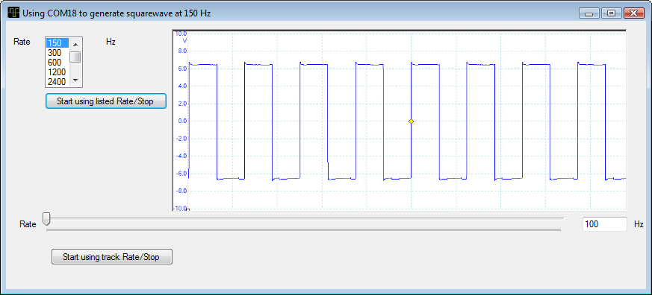
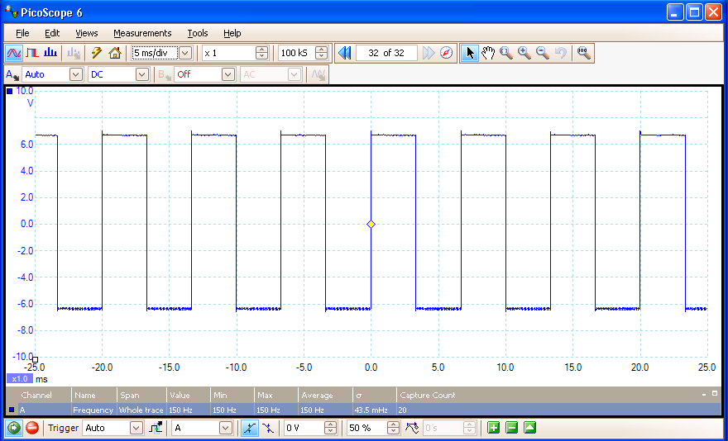
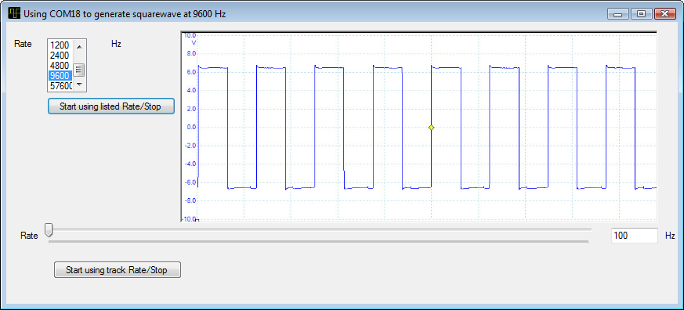
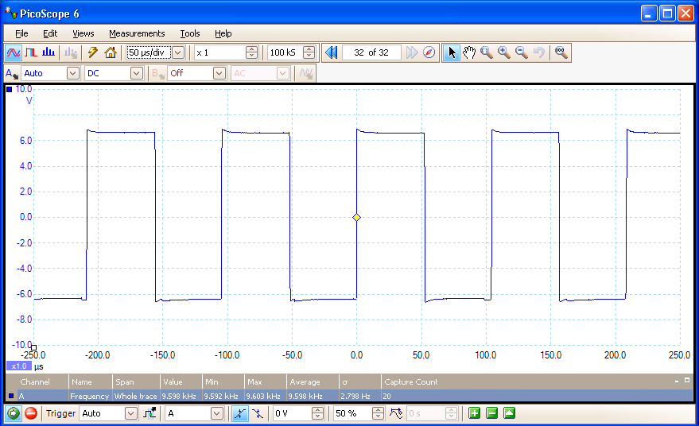
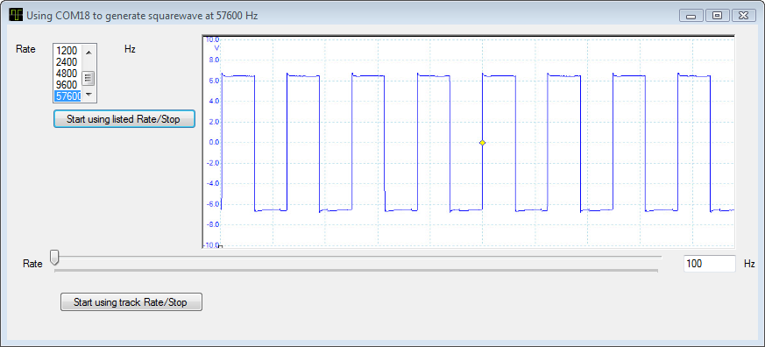
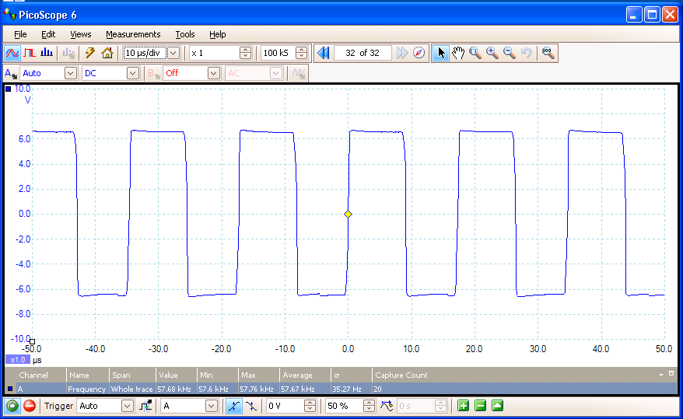

And, now some shots showing non-standard serial rates, which allow continuous frequency selection from 100 Hz to 57600 Hz.
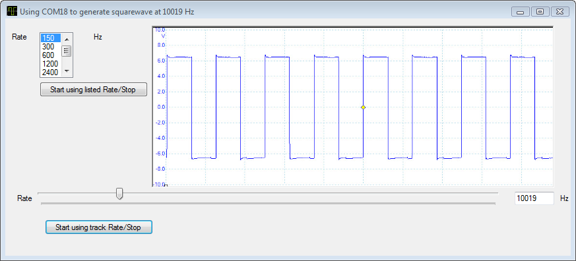
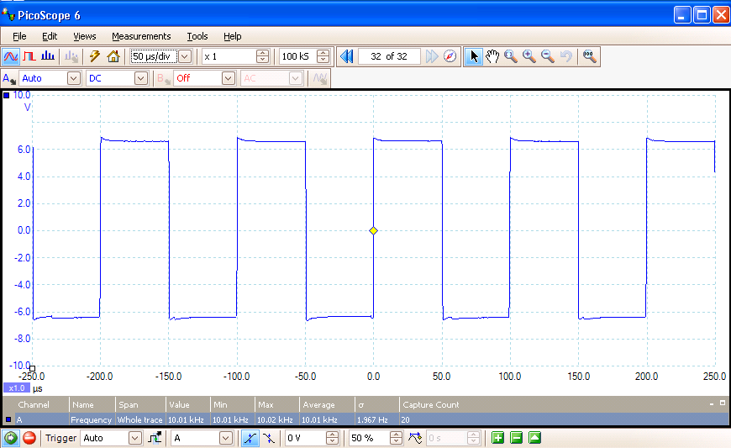
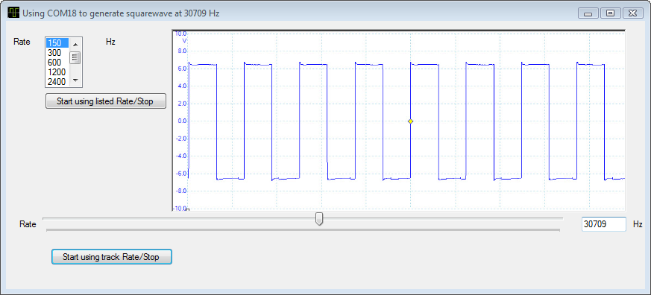
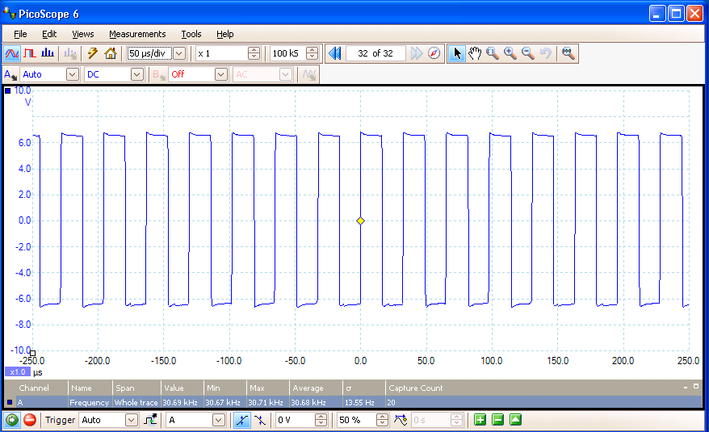
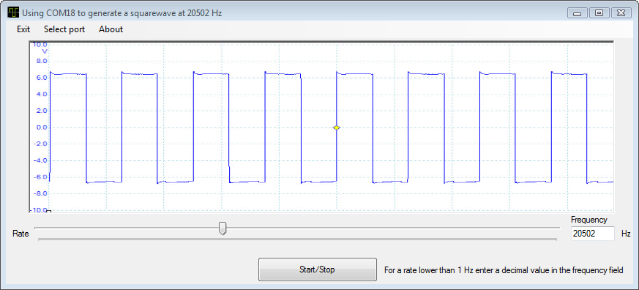

Here is the final form.

