Geiger Counter
Suppose you are attracted to a cheap Geiger Counter from China. Is it a toy, or can it be something more? The answers are… Yes!
Here is one I purchased from Amazon. Its current price is about $50 (I paid more, of course).
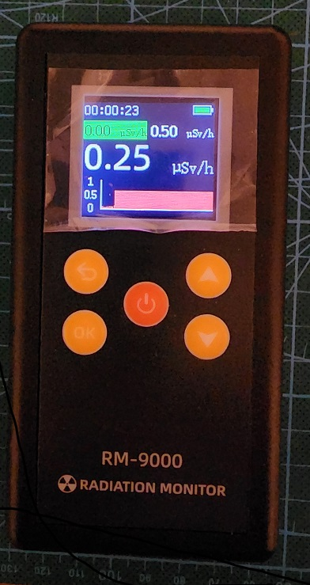
So, what is it good for? Here is where the “toy” answer comes forward. That said, perhaps our “toy-enjoyment” will be enhanced by overcoming some of the more obvious limitations of this and similar CCED (cheap Chinese electronic device).

What are its limitations?
- It has a manual. Of sorts. Useful? Not really.
- Power is 2-AAA 1.5V cell, for 3V total. Battery life is 4-6 hours in continuous operation.
- There is no way to export data, so continuous operation isn’t really needed. (see below)
- The LCD screen is bright and readable. The data displayed are approximate values for radiation dose in Sv/h. The plot is a strip-chart that spans about 70 seconds. The “Y” axis of the strip-chart X (time) and Y (intensity) are not scaled. There are two numeric displays of Sv/h (dosage). I presume that the centered number represents current intensity and the upper-left number represents and average over some time-window (perhaps the same 70 seconds of the chart; perhaps some other time. The background-color of field is shown in Green for background radiation levels and Red for higher-than-normal radiation levels.
- While the sales listing and manual imply that dosage may be displayed in Roentgens (R), I could not work out how to accomplish that.
- Each ionization event that is detected by the Geiger Mueller tube is annunciated as either a click (single event) or a beep (multiple events), but these are hard to correlate with data on the LCD.
- There is no way to calibrate the unit, though such calibration would require non-volatile memory, which it may or may not have. I found no evidence of any non-volatile memory.
- The biggest limitation, in my opinion, is that there is no way to archive and annotate data, thus relegating it to manual “record reading on paper.”
The result is, “Fun Toy!”
I want more. I want something that is in the category: ” Amateur Scientist 3000,” to conflate some terms.
- Manual. Perhaps this document.
- Power: External supply (from the PC), not 2-AAA battery cells.
- A PC connection. So, I can power it using USB and retrieve data over USB.
I want to display strip charts over sufficiently long intervals to provide a good overview of operation. Numeric displays of counts, Sv/h, R/h, and other statistics.
I want to be able to apply calibration (though any such calibration is more guess-work than real science).
I want to record all gathered data and annotations to a file on the PC so that long-term histories are possible; weeks and months will be possible.
Here are the steps that I used to achieve this less-than-lofty goal.
- I used an Arduino Nano board to interface between the Geiger Counter module and the PC. The Arduino connect to the Geiger Counter using 3 wires. One connection is the 3.3V output from the Arduino to provide power to the Geiger Counter. A second connection is use to read pulses from the piezoelectric sounder/speaker of the Geiger Counter to count “clicks.” Lastly, the third connection is between the Arduino ground bus and the Geiger Counter ground. This is both the power and signal return path(s). Red= 3.3V, Blue = piezoelectric sounder, and Black = ground.
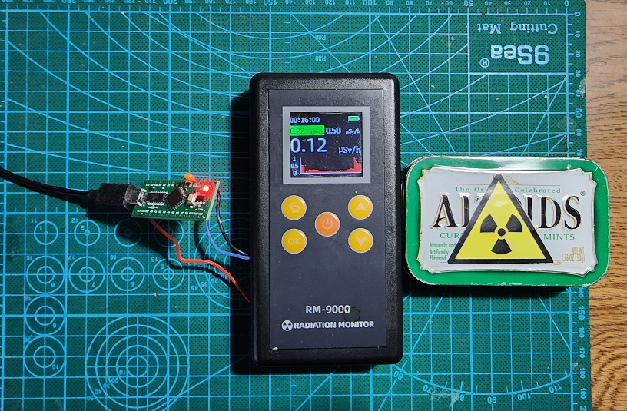

I used the Altoids box to store my small radioactive sample. The sample is quite safe, so the label is just for fun.

The Arduino code (sketch) is quite simple. An interrupt service routine counts pulses from the Geiger Counter piezoelectric sounder. The main loop accumulates uses the pulses accumulated each 10 second interval and sends a calculated count derived from these pulses serially to the PC over the USB connection, appropriately formatted to allow the PC to identify that the board is working and the current summary count from the Geiger Counter.

While this sounds simple, and it is, requiring only a couple dozen lines of C++ code, there is one “complexity” that the code must handle. I glossed over what the signal from the Geiger Counter piezoelectric sounder really represents. Here are images captured from my oscilloscope that shows that signal:

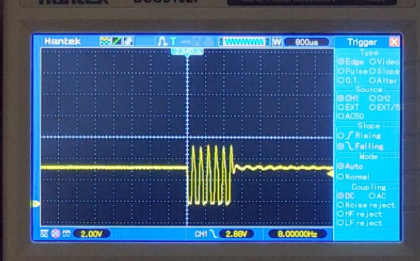

and another,

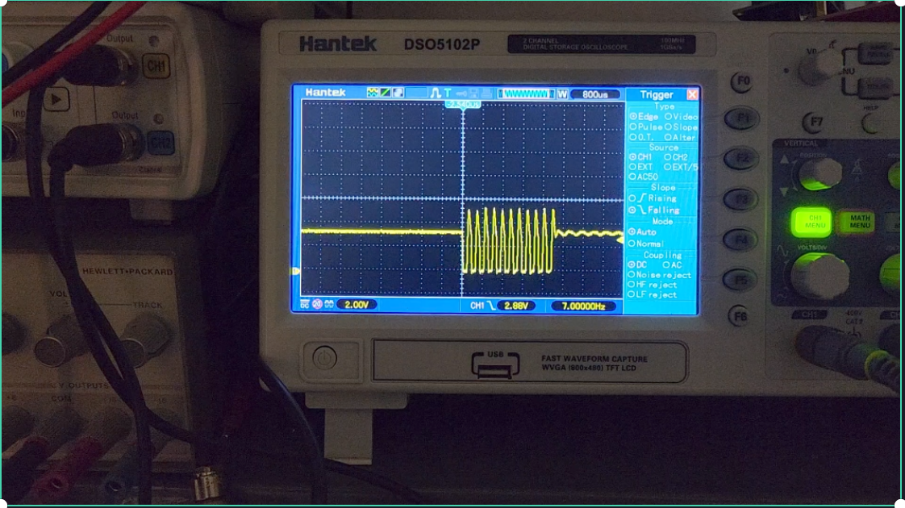
Each of these represents a single “click.” The series of pulses is a form of modulation that excites the piezoelectric sounder, which like any speaker responds to an alternating waveform. If these pulses are extended in duration the sound is heard as a tone at the frequency of the pulses, not just a “click.” I have observed sets of pulse/tone from as short as 6 pulses to as long as 20. I suspect some higher radiation levels may have an even longer set of pulses
What can we conclude (assume) from these observations? My conclusion is that a single Geiger Mueller discharge even averages 9 pulses. This estimation may be close. Thus, the Arduino interrupt service routine will be called for each small pulse in group of multiple pulses that represent a single event. The code divides this raw pulse count by 9 (still an estimate) and sums those pulses over a 10 second interval to return an estimate of the Geiger Counter “counts.” This is all, very, very rough. However, further reduction of these “counts” in the PC application and then applying a fudge-factor (calibration) allows me to claim a result. That result should be considered to be approximate, probably within one order of magnitude of what a professional instrument, costing 1000X or more might reveal. As has often been stated, “Close enough for government work!”
Here is the Arduino sketch, which may be modified to suit your needs.
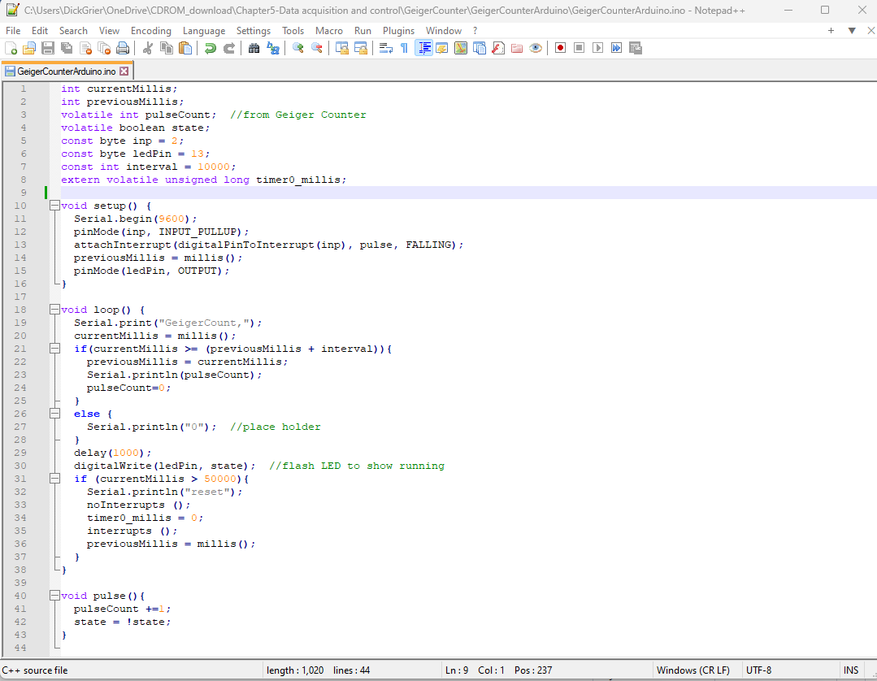
The following may be copied and pasted; do not be distracted by the “Word squigglies.”
int currentMillis;
int previousMillis;
volatile int pulseCount; //from Geiger Counter
volatile boolean state;
const byte inp = 2;
const byte ledPin = 13;
const int interval = 10000;
extern volatile unsigned long timer0_millis;

void setup() {
Serial.begin(9600);
pinMode(inp, INPUT_PULLUP);
attachInterrupt(digitalPinToInterrupt(inp), pulse, FALLING);
previousMillis = millis();
pinMode(ledPin, OUTPUT);
}

void loop() {
Serial.print("GeigerCount,");
currentMillis = millis();
if(currentMillis >= (previousMillis + interval)){
previousMillis = currentMillis;
Serial.println(pulseCount);
pulseCount=0;
}
else {
Serial.println("0"); //place holder
}
delay(1000);
digitalWrite(ledPin, state); //flash LED to show running
if (currentMillis > 50000){
Serial.println("reset");
noInterrupts ();
timer0_millis = 0;
interrupts ();
previousMillis = millis();
}
}

void pulse(){
pulseCount +=1;
state = !state;
}

The PC application (source code is included in my book – CDROM download) looks like this.

I applied one addition to the Arduino board. I connected a 1 µF (105) capacitor between the pulse input pin from the Geiger Counter to ground of the Arduino. This is to reduce the magnitude of some larger transients on the pulses. These transients probably are an artifact of the piezoelectric sounder. You can see the yellow capacitor in the image that shows the board connections. This is between the pins of the blue (INPUT) and black (GROUND) wires.
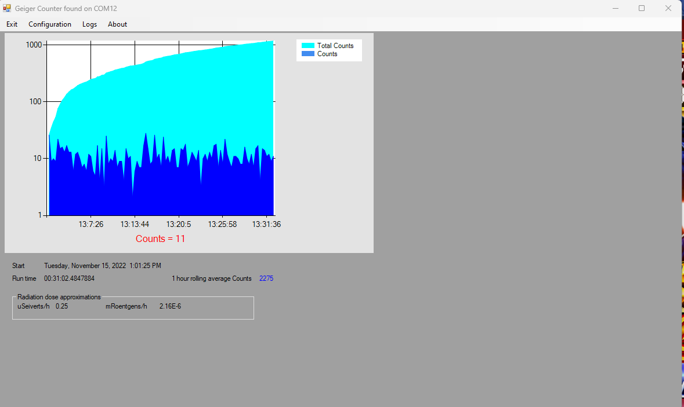
Startup background radiation level

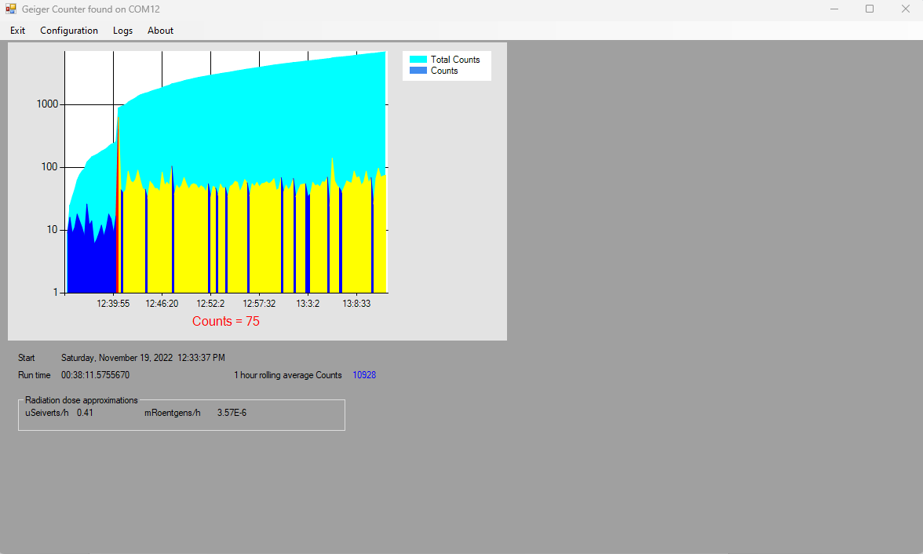
Mixed background level then with sample radioactive source so that I can adjust calibration

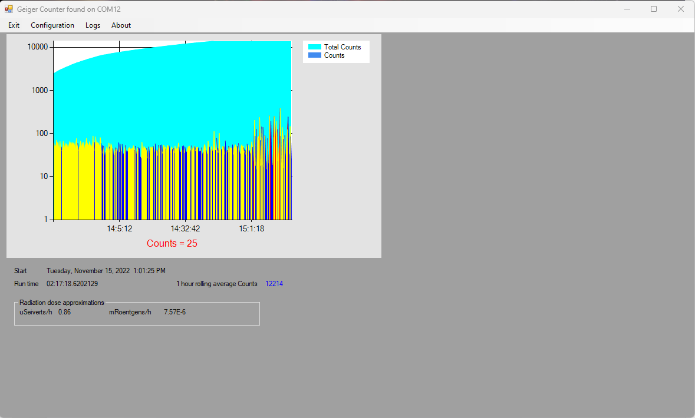
Higher radiation level over an extended time

To personalize the application for your needs, use the Configuration menu.

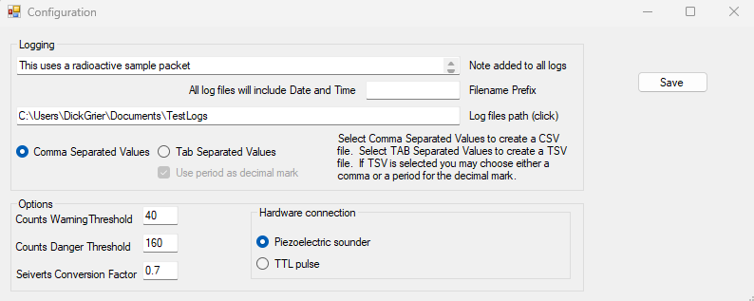
Configuration I have used to resemble the onscreen display to the Geiger Counter LCD

Select a log file location by clicking the Log files path text box. You may select either CSV or TSV log file formats.

Select TTL pulse if you connect the Arduino to a Geiger Counter kit that has a TTL output, such as one from Images Scientific Inc. (imagesco.com) or similar devices that provide a single pulse per “count.” I have not tested this mode, but it should work even better than my cheap Chinese Geiger Counter modified to use the piezoelectric sounder as the source of pulses.

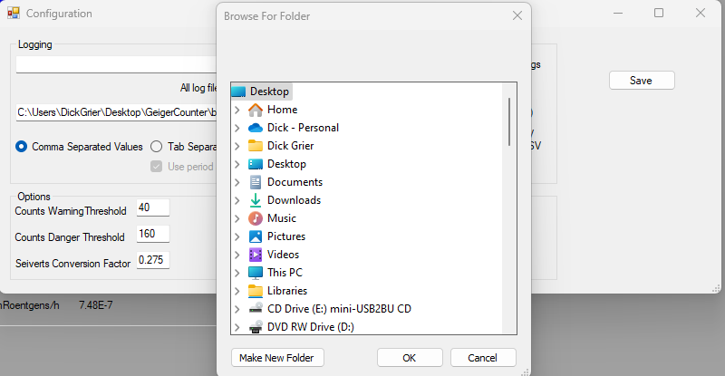
Choose a log file folder

Let me know if you find value here.

Most of the following information is from accepted sources on the internet. Choose your sources with a grain of non-radioactive salt.
You cannot convert counts per minute accurately to Sieverts (Sv) or Roentgens (R) per hour
If you look up information of a Geiger Mueller tube it will often specify how sensitive it is to gamma radiation of a certain isotope. For example, the specification of the widely used LND712 end window tube reads:
Gamma sensitivity: 18 counts per second = 1 mR/h (Co60) [5.56E-5 * counts per second = R/s].
The tube is calibrated against a known gamma source, and the counts per minute to R/h is only valid for gamma radiation emitted by Co-60.
Sieverts to Roentgens Conversion: Sv stands for Sieverts and R stands for Roentgens. The formula used for Sieverts to Roentgens conversion is 1 Sv = 0.0087699999999857 R. In other words, The numeric value of Sieverts is about 114 times larger than the numeric value in Roentgens. Thus, for the sensitivity stated in the preceding paragraph,
Gamma sensitivity: Multiplying the above, 4.87 E-7 * counts/s = Sv/s. Alternately, 1.354E-4 * counts/h = µ S/h.
Here is information from the internet that has useful information about the meaning of Sieverts as a unit of measure. What is Sievert - Unit of Equivalent Dose - Definition (radiation-dosimetry.org)
R stands for roentgens and rem stands for rems. The formula used in roentgens to rems conversion is 1 Roentgen = 11402.5085519 Re\m. In other words, 1 roentgen is 11403 times bigger than a rem.
Why use these different values, Sieverts, Roentgens, and Rem (a unit of effective absorbed dose of ionizing radiation in human tissue, equivalent to one roentgen of X-rays)? History and different applications lend themselves to different nomenclature. You can see a problem here – there are multiple ways to measure and define radiation exposure and these ways can be as confusing and seemingly contradictory.
In real life, all kinds of radiation of different isotopes cause GM tube discharges. A GM tube does not give information about the particle/ray energy, it only indicates that something was able to ionize the gas in the tube. It doesn´t matter whether the tube detected a high energy secondary cosmic ray, or some weak beta particle just being able to penetrate the tube, it will give the same “click.”
However, this does not mean GM tubes are useless. They will detect most beta and gamma radiation and alphas (pancake, end window tubes) so most of the time they will give you information about whether something is radioactive or not, and how radioactive, relative to the background. So, take all information displayed as (Sv or R) as “better than guess-work… but only incrementally better.”
There are also other purposes for Geiger counters in experiments. If you make an array of tubes and connect them to a microcontroller you can actually count particles that come from a certain direction, from space for example. It should also be possible to detect radon daughters decaying by pushing air though a filter and measure the radioactivity of the filter afterwards.
So, even with a `simple` Geiger Muller tube you can perform interesting experiments.
On average, Americans receive a radiation dose of about 0.62 rem (620 millirem) each year. Half of this dose comes from natural background radiation. Most of this background exposure comes from radon in the air, with smaller amounts from cosmic rays and the Earth itself.

What is the average background radiation per year in the United States?
According to the National Council on Radiation Protection and Measurements (NCRP), the average annual radiation dose per person in the U.S. is 6.2 millisieverts (620 millirem). The pie chart below shows the sources of this average dose. Most of our average annual dose comes from natural background radiation.

What is the normal level of background radiation?
Naturally-occurring background radiation is the main source of exposure for most people. Levels typically range from about 1.5 to 3.5 millisievert per year but can be more than 50 mSv/yr.

What is normal background radiation per hour?
That is a level experts describe as minimal, and just below the global average of naturally occurring background radiation of 0.17-0.39 per hour, a range given by the World Nuclear Association.

What percentage of human exposure is background radiation?
As can be seen, natural background radiation, also called “ubiquitous” since it is around us at all times, is the largest source of radiation exposure to humans (50% or about 3.1 mSv).

What is the maximum radiation exposure per year?
Adult: 5,000 Millirems The current federal occupational limit of exposure per year for an adult (the limit for a worker using radiation) is "as low as reasonably achievable; however, not to exceed 5,000 millirems" above the 300+ millirems of natural sources of radiation and any medical radiation.

What level of radiation is safe on a Geiger counter?
So, the background radiation level in my office is varying roughly between 0.05-0.10 uSv/h, which is a normal, safe level of background radiation (see Radiation Units below).

How much radiation can a human take?
Adult: 5,000 millirems. The current federal occupational limit of exposure per year for an adult (the limit for a worker using radiation) is "as low as reasonably achievable; however, not to exceed 5,000 millirems" above the 300+ millirems of natural sources of radiation and any medical radiation.

How much radiation is too much on a Geiger counter?
Exposure to 100 mSv a year is the lowest level at which any increase in cancer risk is clearly evident. A cumulative 1,000 mSv (1 sievert) would probably cause a fatal cancer many years later in five out of every 100 persons exposed to it.

Carnotite is a bright greenish-yellow mineral that occurs typically as crusts and flakes in sandstones. Amounts as low as one percent will color the sandstone a bright yellow. The high uranium content makes carnotite an important uranium ore.

